Date: 14-02-19
Daily Report on WIT & WIL
Name of the faculty : B.V.Kiranmayee Name of the subject : Programming through C
Class/ Section : I B.Tech II sem CSE – A
1 | Grid Reference No : | 3.1
2 | Scenario Reference: | 
3 | Topic Covered: | Linear Search
4 | Linear search is a very simple search algorithm. In this type of search, a sequential search is made over all items one by one. Every item is checked and if a match is found then that particular item is returned, otherwise the search continues till the end of the data collection.  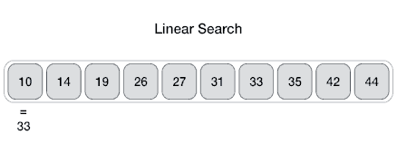  Algorithm  Linear Search ( Array A, Value x)  Step 1: Set i to 1  Step 2: if i > n then go to step 7  Step 3: if A[i] = x then go to step 6  Step 4: Set i to i + 1  Step 5: Go to Step 2  Step 6: Print Element x Found at index i and go to step 8  Step 7: Print element not found  Step 8: Exit  Pseudocode  procedure linear_search (list, value)  for each item in the list  if match item == value  return the item's location  end if  end for  end procedure
5 | Relevant additional illustration if any : Searching Contacts in the Mobile phone
6 | Video links / web links if any: | https://www.youtube.com/watch?v=XuiJ8sLBBTA
7 | Signature of Repository Administrator:

